**# Website_Blocker-for-windows-**

**1) Change extension of script from .py to .pyw**

**2) Open task scheduler**

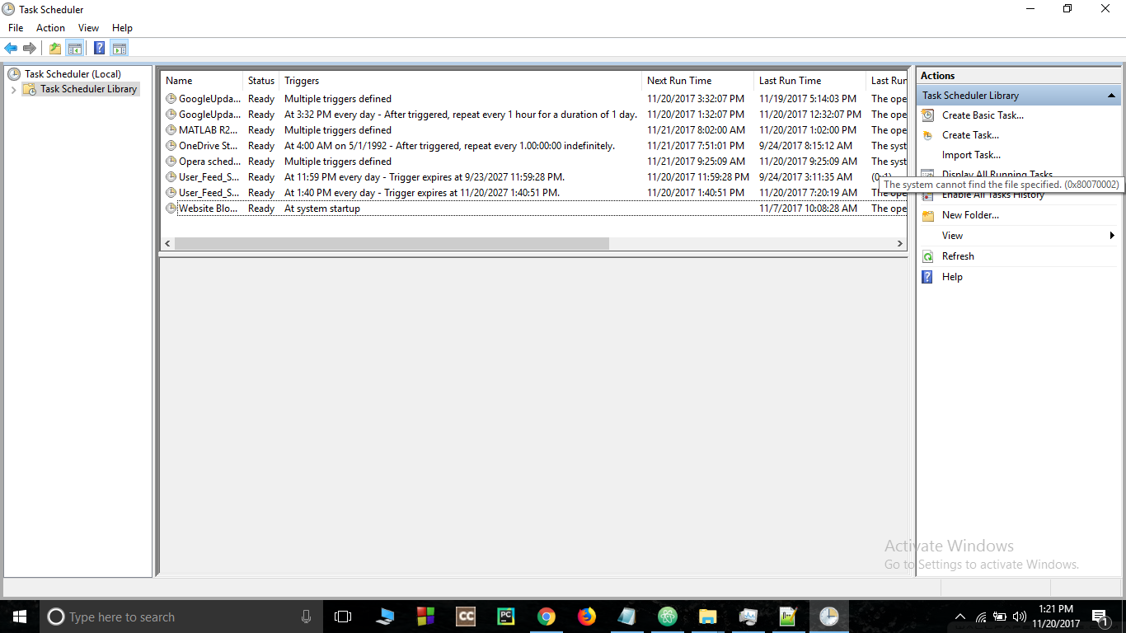

**3) Click on crete task. Give it a name and run with highest privilege**

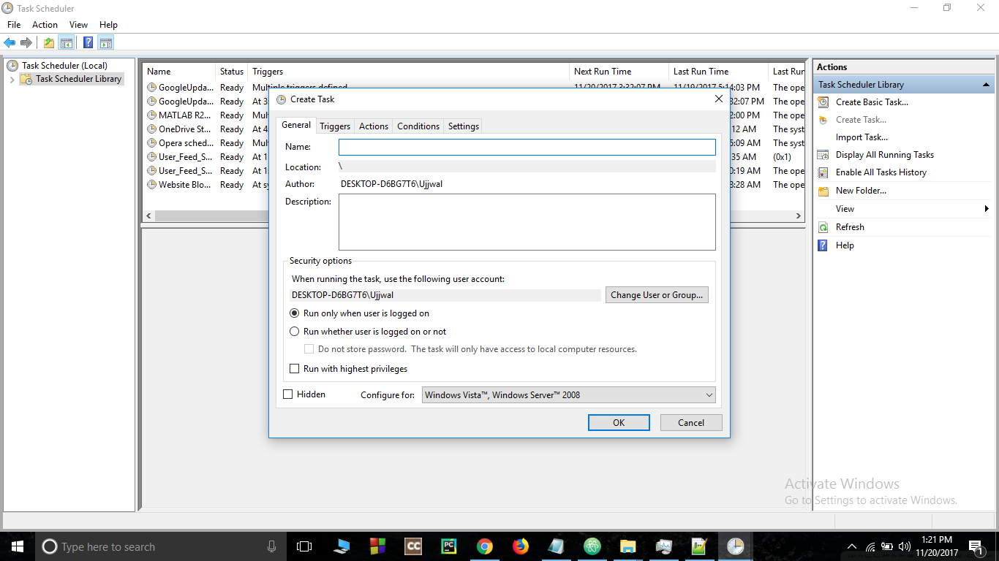

**4) Go to triggers and select "At startup" for begin task**

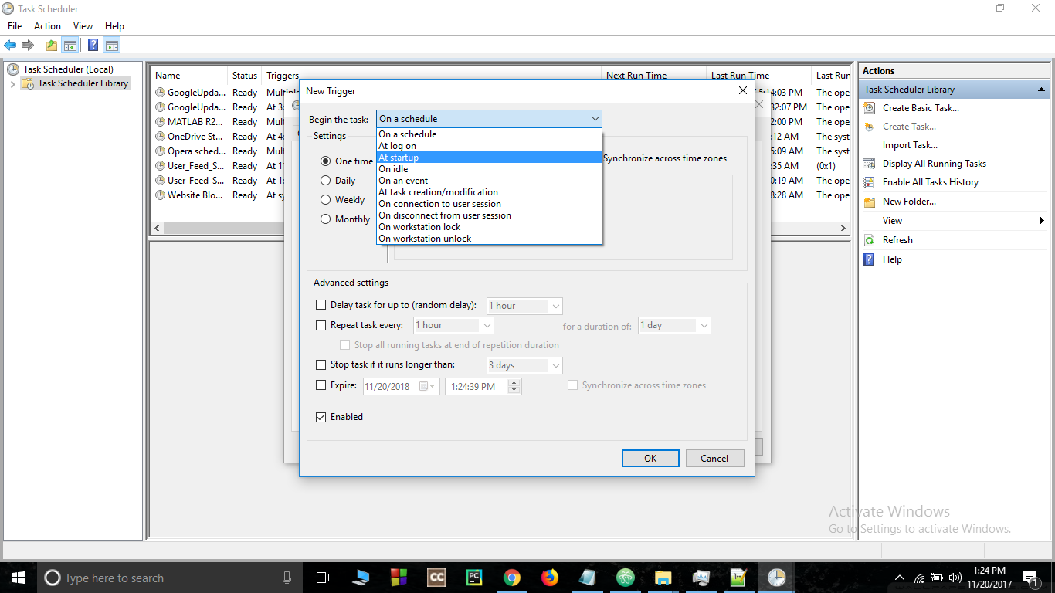

**5) Go to action bar and create a new action and give a path to your script**

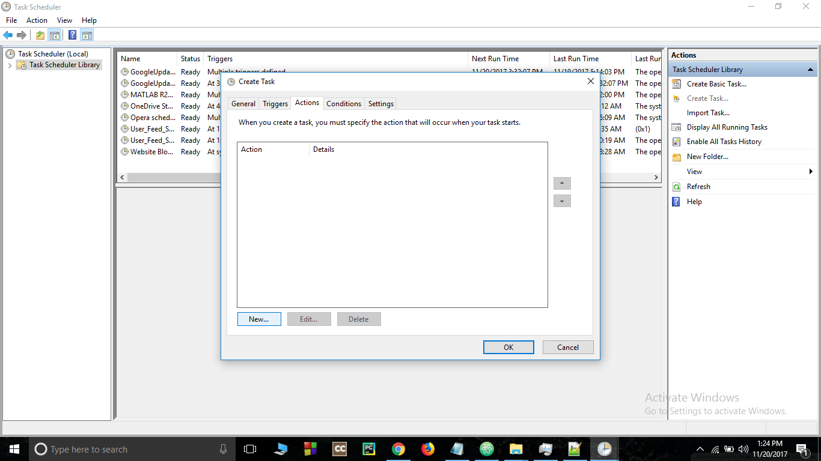

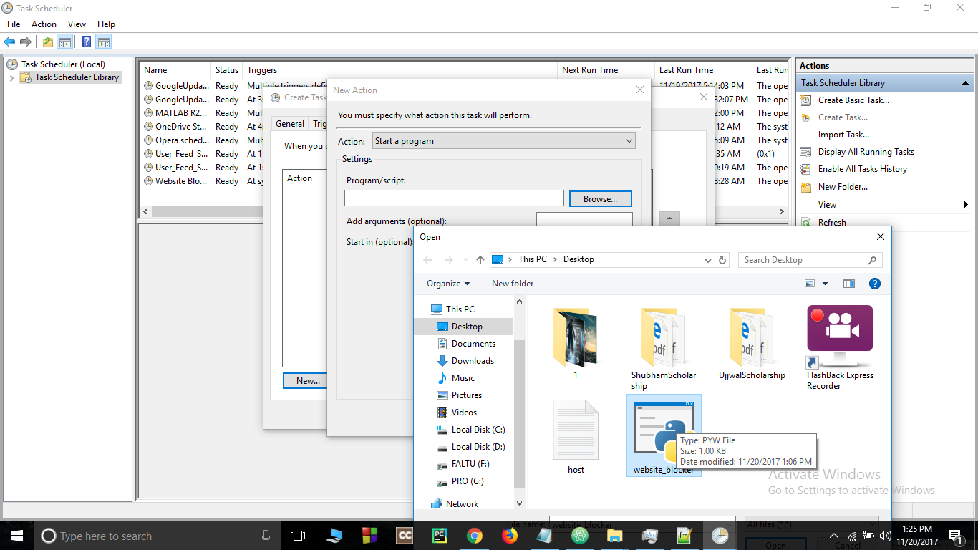

**6) Go to conditions bar and unflag the power section**

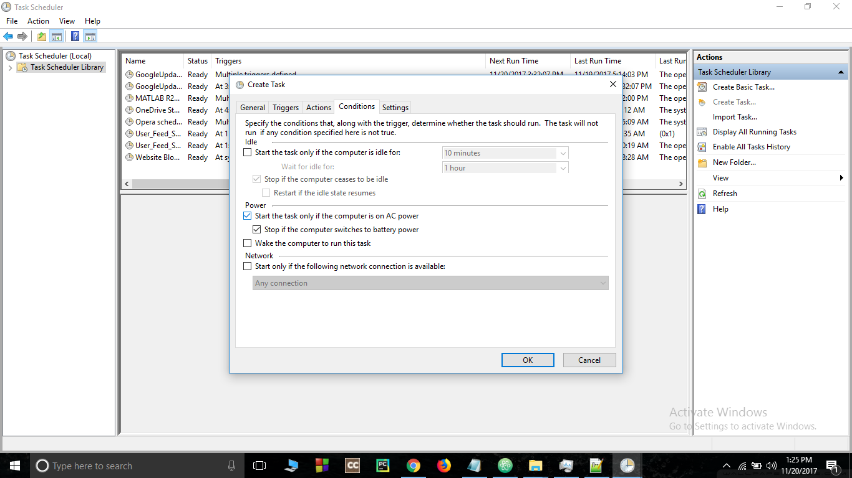

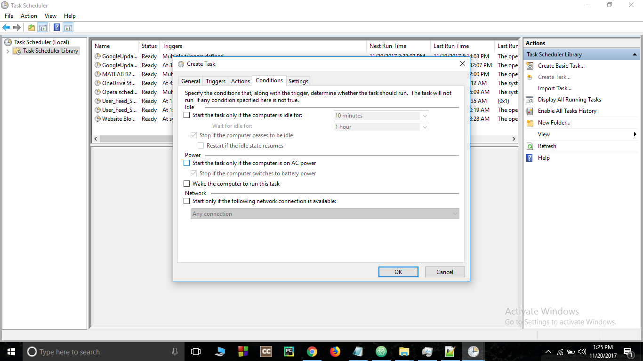

**7) Press OK to schedule your script**

**8) Restart your computer**